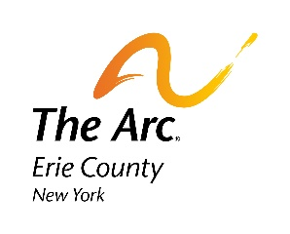
Credit Card Guarantee Form

Please complete and return
To ensure my participation in The Arc Erie County Over the Edge on June 28th 2023, I hereby agree to allow The Arc Erie County New York to charge my credit card listed below on June 25th, 2024 in order to reach my fundraising minimum. I understand that I must commit to raising the $2,000 minimum requirement to guarantee my spot. If that amount is not met by the event date, the difference will be charged to the card below, on June 25th 2024.

Please Accept My: □ Visa □ MasterCard □ American Express

Name as it appears on card:
Card Number:
Expiration Date: |  |  |  | CVV#
Billing Address
City: |  |  | State/Prov: |  | Zip/Postal Code:
Work Phone:
Home Phone:
Signature:
Date:

This form must be received by June 1st, 2024
Please email form to: jtrainor@arceriecounty.org

